AI-powered resume analysis engine: <https://resumeworded.com/results-v2>

<https://www.jobscan.co/>

What to write in the CV

4-5 relevant sections

-Resume Summary (More on this later)

-Work-Ex

-Education

-Internships

-Achievements

-Projects

-Extra-Curriculars

-Anything else that makes u stand out

How to write about your workex:

- Use Action words like Directed/Managed/Spearheaded instead of Duties included

- Convey stories - What was the Problem ? What actions you took? What were the results? What skills did you use & develop?

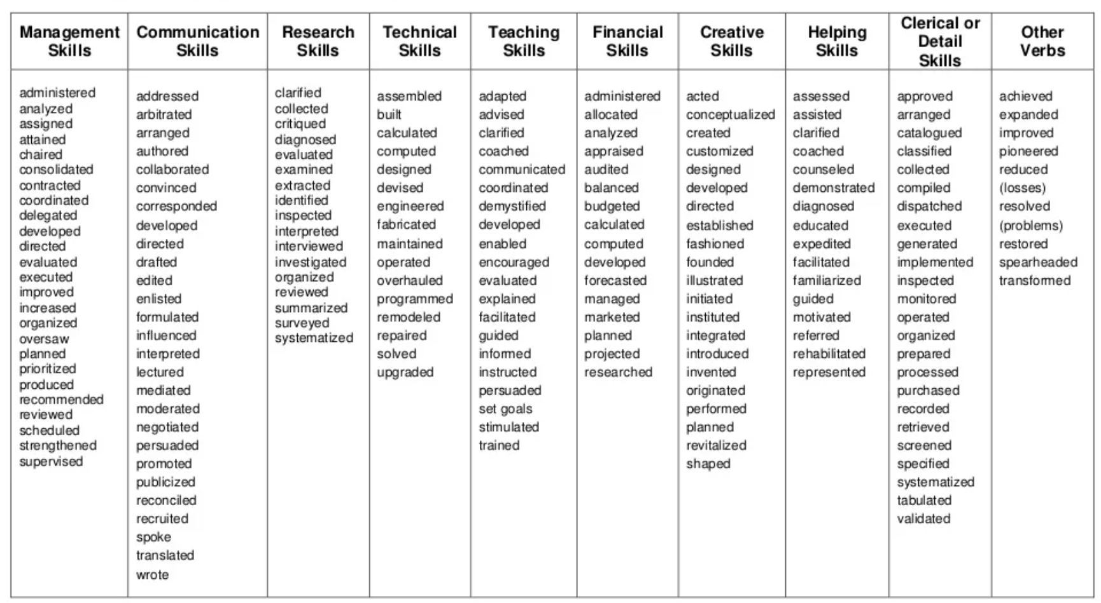

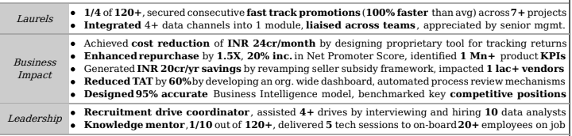

Very IMPORTANT to get shortlisted:

- More than 90% companies now use software (called ATS) to shortlist

- Software checks keywords to match job description (JD)

- Hence, you need TO include relevant keywords in your CV and tailor each CV based on the specific job

Resume Summary:

- Not required for freshers

- Not more than 3 sentences.

- Mention experience, top achievements

- What type of role you are looking at

- Helps in computerized shortlisting if you include relevant keywords

Dos:

- Send file as firstname_lastname, not as cv/resume

- Send pdf file and not as a word file

- Include action words from Job Description

- Choose a neat template

- Fit most points in 1 line

- Length: 1 page for work-ex < 10 yrs, 2 pages max

Donts:

-Don’t make bold claims that cannot be backed up

-Don’t just list job duties; focus on accomplishments

-Avoid personal pronouns (I/me/my)

-Unprofessional email ID like coolguy352

-No need for Photo/DOB

-Don't bold too many words

Common Mistakes:

-Typos/ grammatical errors

-More than 2 lines on any point

- Inconsistent font size/line spacing

- Being unethical like disclosing confidential info

- Verbose resume with length > 2 pages

Technical aspects

-Select a professional font eg Arial/ Calibri/Garamond

- Readable size (10.5-12) for text

- Leave ample white-space so that it is soothing to read

- 1/2-1 inch margins on all sides

- Single spacing works best

For example following is the Job summary for ML Engineer and Data Scientist:

* Strong understanding of Azure environment (PaaS, IaaS) and experience in working with hybrid model.
* Ability to guide and instruct mid-size team of Azure Data Engineers.
* Understand and design/reverse engineering AWS DataSync ETL codes, implement the same data solutions through Azure services.
* Design and build simple to complex ETLs in Azure Data Factory, Synapse Spark Notebooks and Azure DataBricks.
* Should be able to design modules that has security and authorization frameworks.
* Analyze current business practices, processes and procedures and identify future opportunities for leveraging Azure data & analytics PaaS services.
* Minimum 5-10 years of ETL experience using Azure data services
* Analyse and process large sets of structured and unstructured data.
* Optimize machine learning algorithms for performance and scalability.
* Partner with cross functional stakeholders to define a long-term vision for scaling ML/AI applications in production and help teams with their roadmap plannings.
* Provide technical mentorship to Junior Engineers and act as a technical leader for the ML engineering domain.
* Modernize foundational applications
* Prioritize and deploy AI/ML capabilities (enable self-service NLP for document management tool, "Darcy")
* Develop MDM strategy centered on data quality
* Enhance reporting capabilities to support clinical trial growth (ELT vs ETL)
* Data Engineering and Data Modeling skills
* Experience with Extract Transform Load (ETL) pipelines
* Expertise in implementing data warehousing solutions
* Analytical skills for performing data analytics on large datasets
* Strong programming skills in languages like Python, Java, or Scala
* Experience with Big Data and cloud-based technologies like Hadoop, Spark, and AWS
* Understanding of data governance and security principles
* Bachelor's degree in Computer Science, Information Systems, or related field
* Strong communication skills and ability to work independently and collaboratively

Delete these from your CV:

1. Marital status

2. Your high school and primary details if you have attended college

3. Your Religion

4. Your hobbies. Nobody is going to shortlist your CV because you love traveling (Unless it is a travel agent job :).

5. Non-professional email addresses. Ensure that your email address is professional and appropriate for job applications.

6. Long Paragraphs, instead use bullet points to present information clearly and concisely.

7. Irrelevant work experience. Example: you are applying for an accounting job and you indicate that you have been working as a sales executive of XYZ company.

Adding extra stuff just to make your CV longer can hurt your chances. Keep it short and to the point by only including what matters.

*I understand that the hiring manager may be considering candidates from their personal network, but you need to make an effort to demonstrate qualifications and value as a potential candidate*.

The above ⬆️ is for Work Resume:

Cc: @Rakim uddin

#please #share

HOW TO WRITE AN ACADEMIC CV FOR ADMISSION/SCHOLARSHIP ABROAD.

What ACADEMIC CV should include:

📍Your Name (As written on your International passport)

📍Linkedin link, Email address

📍The first column should be your Education

(It should include name of school, name of course, name of supervisor, your research topic and related courses you did in school).

📍Continuing Education (Courses you are doing on either coursera, Udemy, etc)

📍Research Experience

For example,

©️Your Undergraduate work e.g I conducted research in blah blah.

©️I assisted in conducting blah blah ( especially if you helped someone in his or her research or something).

©️I reviewed literature review on two or three papers e.t.c

N.B : You can go online to look for papers to review.

📍Teaching Experience

You can volunteer if you don't have a teaching experience. This experience is very important if you want a teaching assistantship.

📍Professional Experience

📍Publications ( if you have papers fine if not, leave it blank. If it is in review, you can write submitted for review and it should have been published before getting into graduate school).

📍Conferences

📍Honours and Awards

If you are the overall best student in Nursery school, include it. No award is too small🥺)

📍Technical skills ( skills you know how to use very well)

📍Professional Membership, Association(s) you joined during your program

📍Volunteering Experience (It is very very important)

📍Leadership Experience

N.B : To make your academic CV , a very strong one you [can ] attach an hyperlink to everything mentioned in your CV [ Use Google drive to generate a link]. Example: Your certificate, Your transcript, Your continuing Education certificate e.t.c.

Notes:

1. Use Quillbot and Grammarly to check for errors.

2. If your CGPA is not very good, don't add it

